Project Application File
CRYOSTEM Scientific Committee
March 2017 – version 1

Preface

CRYOSTEM is one of the projects selected in 2011 by the French National Research Agency (ANR) in relation to the “Cohorts” call for projects funded under the French government’s “National Investment Programme” (“Investissements d’avenir”).
Launched in July 2012, the CRYOSTEM cohort is a collection of biological samples, taken from allogeneic stem cell transplantation donor-recipients, through which it is hoped to achieve a greater understanding of complications arising from allogeneic transplantations, and whose characteristics are currently poorly understood.
The CRYOSTEM cohort has obtained all the necessary regulatory authorizations from the French Ministry for Higher Education and Research (MESR), the French Patient Protection Committee (CPP), the French Consultation Committee for Data Processing in Healthcare Research (CCTIRS), and the French Data Protection Commission (CNIL). The governance of CRYOSTEM has been certified ISO 9001 in January 2015 for the management of the 33 HSCT Units and 23 BRC network, guaranteeing the quality of the collection and reflecting the commitment of all the acting collaborators.
As of February 28, 2017 the collection comprises more than 4 600 patients and 1 900 donors, more than 155 000 biological samples, including more than 13 000 processed blood samples.
For each blood sample collected, the derived products comprise blood plasma, dried white blood cell pellets, and viable mononuclear cells in Albumin/ DMSO (10%).
Numbers of each sample according to the period (D0, R0, a1, etc.) are available through the CRYOSTEM website (www.cryostem.org).
The sampling schedule, spanning from the pre-transplantation period to two years post-transplantation, is indicated in the diagram below and is performed in case of GvHD appearance. The s3 samplings will be available from November 2019.

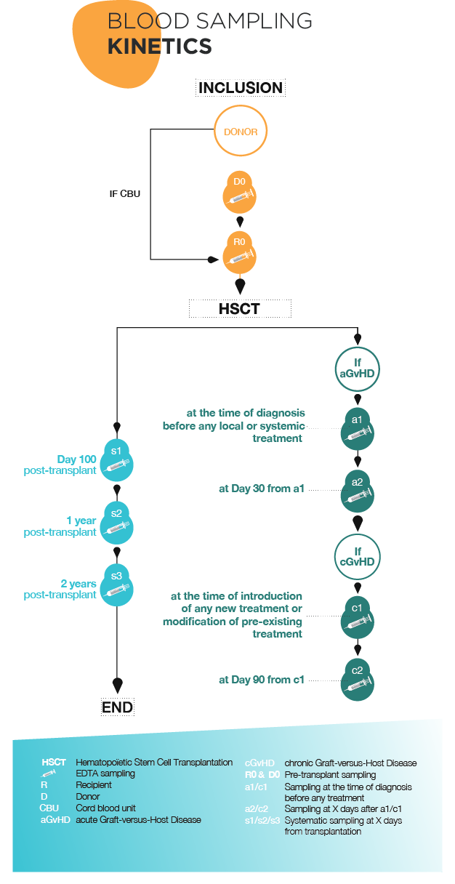

CRYOSTEM collection access

Collection access procedure
Authorization to access the CRYOSTEM collection is granted upon the approval of the CRYOSTEM Scientific Committee, following an evaluation by independent international experts.

Terms and conditions
The projects put forward by the academic and/or commercial members in relation to this Call for Projects must abide by the general terms attached to the application file.
The applicants must acknowledge that they have read and accepted these general terms and the appendices. The selected applicants must agree (and sign) an act of commitment of the general terms that will be sent to them before samples delivery.
The collection users will also have to complete and send the follow-up sheet provided at the moment of samples delivery.
Results of research projects undertaken using Collection samples
A scientific report will be requested at the conclusion of all research undertaken using CRYOSTEM collection samples and could be requested on demand.
To promote the collection with our partners, a review of each scientific project, around half a page in length, written in layman’s terms and aimed at the general public, will be requested from all research teams that enjoy access to the collection; they may also be asked to communicate further with the general public.

Applications

Applications must be compiled by completing the standard application form, entirely in English, including the bibliography. The Layman’s summary only will be written in French. The scientific proposal must not exceed 7 pages. The application file must include all the elements required and needed to the scientific and technical review of the project.
Applications could be submitted by post to the following address:

Association CRYOSTEM
Institut Paoli-Calmettes
For the attention of Claire Fontenille and Emilie Robert
232 boulevard Sainte-Marguerite
13009 Marseille
FRANCE

Or by e-mail : emilie.robert@cryostem.org / claire.fontenille@cryostem.org

Following reception, the application will be transmitted to CRYOSTEM Scientific Committee : the file will be evaluated from the following Scientific Committee session. After approval of the Scientific Committee, the application file will be evaluated by international experts.

Applicants must present their project by completing the standard application form:
- Summary (5 pages)
- Layman’s summary for the general public (1 page), written in French
- Scientific proposal comprising a project overview with reference to the following points (7 pages):
- State of the art and research capabilities of the applicant(s)
- Objectives
- Strategy and methods
- Expected results
- Schedule
- Scientific and technical details regarding sample use
- Prospects and potential applications
- Publications arising from the project
- Proof of funding to access the Collection
- Proof of available research techniques to be implemented

For any question related to the application file, you can contact CRYOSTEM project managers, Emilie Robert (emilie.robert@cryostem.org) et Claire Fontenille (claire.fontenille@cryostem.org).

1. Summary (2 pages)

- Administrative summary

Principal Investigator

Ms Mr

Last name First name

Title and position

Date of birth Nationality

Tel Fax

E-mail

Affiliation (Name and Address)

Principal Investigator’s signature

Details of research teams involved in the Project

Academic partnership Industrial partnership

Team n° | Name of the Head of the Team | Position | Name of the team | Address/ e-mail/telephone number
1
2
3

List of five most prominent publications in the last five years (for all applicant teams)

- Scientific summary

Project title

Thematics

Project type
Fundamental research Translational research

Key words

Abstract (500 words, background, objectives, methods, perspectives)

Duration of the Project

Requested material (biological samples and clinical data)

- Type of Hematopoietic Stem Cell Transplantation
Non-related donor Related donor/Geno-identical
Cord Blood Related donor/ Haplo-identical

- Type of patient
Adult Pediatric

- Number of patients :

- Clinical data
Yes No

- Type of period
D0 (donor pre-transplant) R0 (recipient pre-transplant)
s1/s2 (recipient 100 days and one post-transplant)
a1/a2 (recipient with acute GvHD) c1/c2 ( recipient with chronic GvHD)

- Type of samples
Viable cells in DMSO Dried white blood cell pellets Blood plasma

- Number of samples requested (please specify number of samples by period):

- Rationale for the number and type of samples requested (statistical plan)

Funds required for the project

Nature | Detail | Total (euros)
Material
(biological samples and/or clinical data)*
Human Resources
Equipments
Consumables
Others
TOTAL
*calculated in accordance with the pricing list

2. Layman’s summary for the general public (in French, 1 page)

3. Scientific proposal (in English, 7 pages)

Project overview with reference to the following points:

- State of the art and research capabilities of the applicant(s)
- Objectives
- Strategy and methods
- Expected results
- Schedule
- Scientific and technical details regarding sample use
- Prospects and potential applications
- Publications arising from the project
- Proof of funding to access the Collection
- Proof of available research techniques to be implemented

Annexe 1: Samples pricing-list

Pricing list covering
the provision of samples from the CRYOSTEM Collection
A : Academic project initiator and member of the CRYOSTEM consortium
B : Academic project initiator unaffiliated with the CRYOSTEM consortium
C : Non-academic / private / commercial project initiator
by aliquot* | A |  | B | C
mononuclear cells in DMSO | 12,00 € |  | 15,00 € | 42,00 €
dry precipitate | 9,00 € |  | 11,25 € | 31,50 €
plasma | 8,00 € |  | 10,00 € | 28,00 €
nitrogen storage (per year)¹ | 0,80 € |  | 1,00 € | 2,80 €
removal from storage (flat rate)² | 5,40 € |  | 6,75 € | 18,90 €
blood sample (flat rate) | 8,80 € |  | 11,13 € | 30,80 €
by patient** | A |  | B | C
selection and unpacking of aliquots | 15,00 € |  | 18,75 € | 52,50 €
by project | A |  | B | C
extraction of clinical data | 280,00 € |  | 350,00 € | 700,00 €
by group from 1 to 200 aliquots** | A |  | B | C
shipment (flat rate)³ | 225,00 € |  | 225,00 € | 225,00 €
centralisation⁴, control and shipment to the PI (flat rate) | 46,00 € |  | 57,50 € | 161,00 €
* Single aliquot = 1 x 2ml cryotube
¹ To be multiplied by the storage duration for each aliquot set at 2 years
² Including extracting biological data
** Unlimited number of aliquots for a single patient
³ To be multiplied by the number of expeditions to the CryoStem platform in Marseille and then onwards to the Project initiator
⁴ Shipment in dry ice from CRB partners to the CryoStem platform, then onwards to the Project initiator

