**Project Application File**

**CRYOSTEM Scientific Committee**

March 2018 – version 2

**Preface**

CRYOSTEM is one of the projects selected in 2011 by the French National Research Agency (ANR) in relation to the “Cohorts” call for projects funded under the French government’s “National Investment Programme” (“*Investissements d’avenir*”).

Launched in July 2012, the CRYOSTEM cohort is a collection of biological samples, taken from allogeneic stem cell transplantation donor-recipients, through which it is hoped to achieve a greater understanding of complications arising from allogeneic transplantations, and whose characteristics are currently poorly understood.

The CRYOSTEM cohort has obtained all the necessary regulatory authorizations from the French Ministry for Higher Education and Research (MESR), the French Patient Protection Committee (CPP), the French Consultation Committee for Data Processing in Healthcare Research (CCTIRS), and the French Data Protection Commission (CNIL). The governance of CRYOSTEM has been certified ISO 9001 in January 2015 for the management of the 33 HSCT Units and 23 BRC network, guaranteeing the quality of the collection and reflecting the commitment of all the acting collaborators.

As of January 1st, 2018 the collection comprises more than 5 500 patients and 2 300 donors, more than 190 000 biological samples, including more than 15 800 processed blood samples.

For each blood sample collected, the derived products comprise blood plasma, dried white blood cell pellets, and viable mononuclear cells in Albumin/ DMSO (10%).

Numbers of each sample according to the period (D0, R0, a1, etc.) are available through the CRYOSTEM website ([www.cryostem.org](http://www.cryostem.org)).

The sampling schedule, spanning from the pre-transplantation period to two years post-transplantation, is indicated in the diagram below and is performed in case of GvHD appearance. The s3 samplings will be available from November 2018.

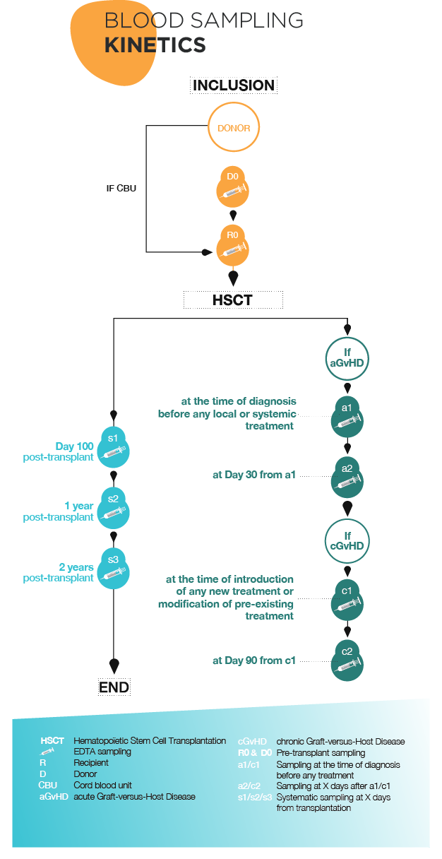

**CRYOSTEM collection access**

**Collection access procedure**

Authorization to access the CRYOSTEM collection is granted upon the approval of the CRYOSTEM Scientific Committee, following an evaluation by independent international experts.

**Terms and conditions**

The projects put forward by the academic and/or commercial members in relation to this Call for Projects must abide by the general terms attached to the application file.

The applicants must acknowledge that they have read and accepted these general terms and the appendices. The selected applicants must agree (and sign) an act of commitment of the general terms that will be sent to them before samples delivery.

The collection users will also have to complete and send the follow-up sheet provided at the moment of samples delivery.

**Results of research projects undertaken using Collection samples**

A scientific report will be requested at the conclusion of all research undertaken using CRYOSTEM collection samples and could be requested on demand.

To promote the collection with our partners, a review of each scientific project, around half a page in length, written in layman’s terms and aimed at the general public, will be requested from all research teams that enjoy access to the collection; they may also be asked to communicate further with the general public.

**Applications**

Applications must be compiled by completing the standard application form, **entirely in English**, including the bibliography. **The Layman’s summary only** will be written in French. The scientific proposal must not exceed **7 pages**. The application file must include all the elements required and needed to the scientific and technical review of the project.

Applications could be submitted by e-mail to the project managers : [emilie.robert@cryostem.org](mailto:emilie.robert@cryostem.org) or claire.fontenille@cryostem.org

Following reception, the application will be transmitted to CRYOSTEM Scientific Committee : the file will be evaluated from the following Scientific Committee session. Following the preselection, the applicant coulb be asked to bring additional information to his project or to reconsider some parts of his project. After approval of the Scientific Committee, the application file will be evaluated by international experts. The Scientific Committee is the only responsible for the final selection.

**Applicants must present their project by completing the standard application form**:

1. Summary
2. Layman’s summary for the general public (1 page), written in French
3. Scientific proposal comprising a project overview with reference to the following points (7 pages):
4. State of the art and research capabilities of the applicant(s)
5. Objectives
6. Strategy and methods
7. Expected results
8. Schedule
9. Scientific and technical details regarding sample use
10. Prospects and potential applications
11. Publications arising from the project
12. Proof of funding to access the Collection
13. Proof of available research techniques to be implemented

For any question related to the application file, you can contact CRYOSTEM project managers, Emilie Robert ([emilie.robert@cryostem.org](mailto:emilie.robert@cryostem.org)) and Claire Fontenille (claire.fontenille@cryostem.org).

**1. Summary**

1. **Administrative summary**

**Principal Investigator**

Ms  Mr

Last name First name

Title and position

Date of birth Nationality

Tel Fax

E-mail

**Affiliation (Name and Address)**

Academic PI member of CRYOSTEM consortium

Academic PI non-member of CRYOSTEM consortium

Non academic / Private / Industrial PI

**Principal Investigator’s signature**

**Details of research teams involved in the Project**

Academic partnership Industrial partnership

|  |  |  |  |  |
| --- | --- | --- | --- | --- |
| **Team n°** | **Name of the Head of the Team** | **Position** | **Name of the team** | **Address/ e-mail/telephone number** |
| **1** |  |  |  |  |
| **2** |  |  |  |  |
| **3** |  |  |  |  |

**List of five most prominent publications in the last five years** *(for all applicant teams)*

1. **Scientific summary**

**Project title**

**Thematics**

**Project type**

Fundamental research Translational research

**Key words**

***Abstract*** *(500 words, background, objectives, methods, perspectives)*

**Duration of the Project**

**Requested material (biological samples and clinical data)**

* Type of Hematopoietic Stem Cell Transplantation

Non-related donor  Related donor/Geno-identical

Cord Blood  Related donor/ Haplo-identical

* Type of patient

Adult  Pediatric

* Number of patients :
* Clinical data

Yes  No

If yes, precise :

* Other data required (i.e. complete blood count, liver enzymes… please, ask before CRYOSTEM project managers for the data availability)

Yes  No

If yes, precise :

Remark: any additional data for which a specific demand would be asked for at the time of the application would not be provided.

* Type of period

D0 (donor, pre-transplant)  R0 (recipient, pre-transplant)

s1 (recipient, 100 days post-transplant)

s2 (recipient, one year post-transplant)

a1 (recipient, at the acute GvHD occurrence)

a2 (recipient, one month after the acute GvHD occurrence)

c1 (recipient, at the chronic GvHD occurrence)

c2 (recipient, three months after the chronic GvHD occurrence)

* Type of samples

Viable cells in DMSO (mean concentration of 8 x 106 cells/ml per aliquot before thawing and washing, with a mean cell recovery rate following thawing and washing of 50%)

Dried white blood cell pellets (mean DNA quantity of 2µg/106 cells per aliquot)

Blood plasma (mean volume of 1 ml per aliquot)

* Number of samples requested *:*

*For the calculation, use the following table :*

|  |  |  |  |  |  |
| --- | --- | --- | --- | --- | --- |
| **Period** | **Number of patients** | **Viable cells in DMSO :**  **number of aliquots/period\*** | **Dried white blood cell pellets : number of aliquots/period\*** | **Blood plasma : number of aliquots/period\*** | **TOTAL** |
|  |  |  |  |  |  |
|  |  |  |  |  |  |
|  |  |  |  |  |  |
|  |  |  |  |  |  |
|  |  |  |  |  |  |
| **Total number of samples** | | | | |  |

*\*depending on the quantities needed for experiments and the one available per aliquot.*

* Rationale for the number and type of samples requested *(statistical plan)*
* Have you plan to use all the samples asked for ?

Yes  No

If no, please remind to send CRYOSTEM a samples destruction certificate .

**Funds required for the project**

* Description of the costs items

|  |  |  |
| --- | --- | --- |
| **Nature** | **Detail** | **Total (euros)** |
| **Material**  **(biological samples and/or clinical data)\*** | Samples |  |
| Selection, removal from storage and unpacking of aliquots |  |
| Blood sampling |  |
| Clinical data extraction |  |
| Extraction of other data (i.e. complete blood count…) |  |
| Shipment |  |
| Centralization and control |  |
| **Sub-total for the provision of samples** |  |
| **Human Resources** |  |  |
|  |  |
|  |  |
| **Equipments** |  |  |
|  |  |
|  |  |
| **Consumables** |  |  |
|  |  |
|  |  |
| **Others** |  |  |
|  |  |
| **TOTAL** | |  |

*\*calculated in accordance with the pricing list. A samples allocation quotation would be provided to the PI by CRYOSTEM project managers.*

* Funding status

Acquired :

* Precise the name of the requested institution/ organisation :

For the CRYOSTEM samples access

For the other cost items

Ongoing application :

* Precise the name of the requested institution/ organisation :

For the CRYOSTEM samples access

For the other cost items

None :

* Would you want to integrate the « HTC Project »*, in order to be granted, if possible, to fund the CRYOSTEM samples and the other cost items ?

Yes  No

*The « HTC Project » is an international programme, created by CRYOSTEM, to promote the research in the field of HSCT complications. Following international experts evaluation, only the CRYOSTEM Scientific Committee would decide of the project integration and funding by « the HTC Project », according to its scientific relevance, its total cost and the available financial ressources of the endowment fund « HTC Project ».

**2. Layman’s summary for the general public (in French, 1 page)**

**3. Scientific proposal (in English, 7 pages)**

Project overview with reference to the following points:

1. State of the art and research capabilities of the applicant(s)
2. Objectives
3. Strategy and methods
4. Expected results
5. Schedule
6. Scientific and technical details regarding sample use
7. Prospects and potential applications
8. Publications arising from the project
9. Proof of funding to access the Collection
10. Proof of available research techniques to be implemented

**Annexe 1: Samples pricing-list**

