**Project Application File**

**CRYOSTEM Scientific Committee**

Version 7 – April 2021

**Preface**

CRYOSTEM is one of the projects selected in 2011 by the French National Research Agency (ANR) in relation to the “Cohorts” call for projects funded under the French government’s “National Investment Programme” (“*Investissements d’avenir*”).

Launched in July 2012, the CRYOSTEM cohort is a collection of biological samples, taken from allogeneic stem cell transplantation donor-recipients, through which it is hoped to achieve a greater understanding of complications arising from allogeneic transplantations, and whose characteristics are currently poorly understood.

The CRYOSTEM cohort has obtained all the necessary regulatory authorizations from the French Ministry for Higher Education and Research (MESR), the French Patient Protection Committee (CPP), the French Consultation Committee for Data Processing in Healthcare Research (CCTIRS), and the French Data Protection Commission (CNIL). The governance of CRYOSTEM has been certified ISO 9001 in January 2015 for the management of the all French HSCT Units and 28 BRC (Biological Resources Centres) network currently, guaranteeing the quality of the collection and reflecting the commitment of all the acting collaborators.

As of January 1st, 2021 the collection comprises more than 5 900 patients and 2 400 donors, more than 200 000 biological samples, resulting from more than 17 800 processed blood samples.

For each blood sample collected, the derived products comprise blood plasma, dried white blood cell pellets, and viable mononuclear cells in Albumin/ DMSO (10%).

Numbers of each sample according to the period (D0, R0, a1, etc.) are available through the CRYOSTEM website ([www.cryostem.org](http://www.cryostem.org)).

The sampling schedule, spanning from the pre-transplantation period to two years post-transplantation, is indicated in the diagram below and is performed in case of GvHD appearance.

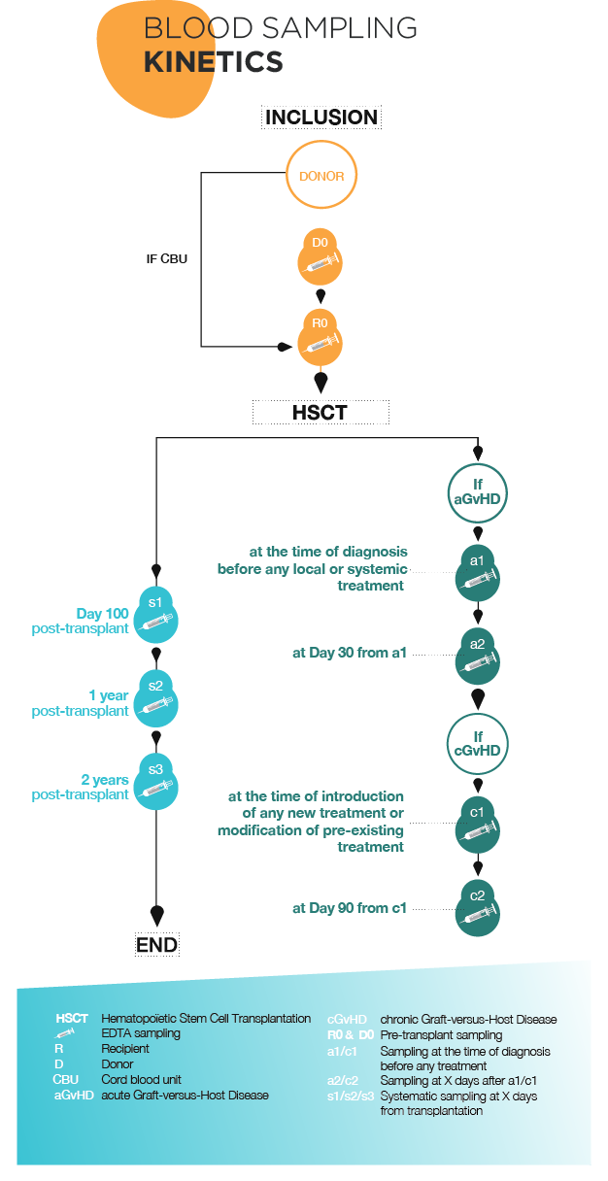

**CRYOSTEM collection access**

**Collection access procedure**

Authorization to access the CRYOSTEM collection is granted upon the approval of the CRYOSTEM Scientific Committee, following an evaluation by independent international experts.

**Terms and conditions**

The projects put forward by the academic and/or commercial members in relation to this Call for Projects must abide by the general terms attached to the application file.

The applicants must acknowledge that they have read and accepted these general terms and the appendices. The selected applicants must agree (and sign) an act of commitment of the general terms that will be sent to them before samples delivery.

The collection users will also have to complete and send the follow-up sheet provided at the moment of samples delivery.

**Results of research projects undertaken using Collection samples**

A scientific report will be requested at the conclusion of all research undertaken using CRYOSTEM collection samples and could be requested on demand.

To promote the collection with our partners, a review of each scientific project, around half a page in length, written in layman’s terms and aimed at the general public, will be requested from all research teams that enjoy access to the collection; they may also be asked to communicate further with the general public.

**Applications**

Applications must be compiled by completing the standard application form, **entirely in English**, including the bibliography. **The Layman’s summary only** will be written in French. The scientific proposal must not exceed **7 pages**. The application file must include all the elements required and needed to the scientific and technical review of the project.

Applications could be submitted by e-mail to the strategy & valorisation manager : [emilie.robert@cryostem.org](mailto:emilie.robert@cryostem.org).

Following reception, the application will be transmitted to CRYOSTEM Scientific Committee : the file will be evaluated from the following Scientific Committee session. Following the preselection, the applicant could be asked to bring additional information to his project or to reconsider some parts of his project. After approval of the Scientific Committee, the application file will be evaluated by international experts. The Scientific Committee is the only responsible for the final selection.

**Applicants must present their project by completing the standard application form**:

1. Summary
2. Layman’s summary for the general public (1 page), written in French
3. Scientific proposal comprising a project overview with reference to the following points (7 pages):
4. State of the art and research capabilities of the applicant(s)
5. Objectives
6. Strategy and methods
7. Expected results
8. Schedule
9. Scientific and technical details regarding sample use
10. Prospects and potential applications
11. Publications arising from the project
12. Proof of funding to access the Collection
13. Proof of available research techniques to be implemented

For any question related to the application file, you can contact Emilie Robert, strategy & valorization manager ([emilie.robert@cryostem.org](mailto:emilie.robert@cryostem.org)).

By transmitting your project application, you declare that you have obtained the agreement of the other persons whose name appear in this file and you acknowledge that you have read the conditions under which your personal data are processed by CRYOSTEM as presented below:

The personal data collected in your application file is processed for the legitimate purposes of supporting the evaluation of your project, managing the relationship with you, setting-up the research convention should your project be accepted, and promoting the CRYOSTEM cohort. As part of the promotion of the research conducted with the CRYOSTEM cohort, our communication partner may contact you to propose recording an interview, providing that you give us consent to be contacted for this purpose. Only those data strictly necessary to fulfil these objectives are collected and processed, in particular, the data related to your identity and contact information, as well as your professional affiliation.

We do not transmit your personal data to any recipient other than the members of the staff of CRYOSTEM, the members of the Scientific Committee, and our communication partner who processes personal data from researchers on our behalf and according to our instructions. We store your personal data for a maximum duration of ten years following the end of the relationship with you or the end of the research convention. The documents are then archived after having been anonymized.

CRYOSTEM as data controller complies to the General Data Protection Regulation (GDPR) (EU) 2016/679 as well as the relevant dispositions from the French national data protection law (Loi Informatique et Libertés). You can exercise a right of access, a right to rectification or to erasure of your data. You can also, at any time, object or exercise a right to restriction of its processing. For any request regarding the processing of your personal data, please contact us at the following email address: [dpo@cryostem.org](mailto:dpo@cryostem.org)

If you consider that we have not properly respected your rights, you have also the ability to lodge a complaint with the data protection supervisory authority from the country where you are established (if you are located in the European Union). If you are located in France, or outside the European Union, your complaint can be lodged at the “Commission Nationale de l’Informatique et des Libertés (CNIL), on: [www.cnil.fr](http://www.cnil.fr).

**1. Summary**

1. **Administrative summary**

**Principal Investigator**

Ms  Mr

Last name : First name :

Title and position :

Date of birth : Nationality :

Tel : Fax :

E-mail :

**Affiliation (Name and Address) :**

Academic PI member of CRYOSTEM consortium

Academic PI non-member of CRYOSTEM consortium

Non-academic / Private / Industrial PI

**Principal Investigator’s signature**

**Details of research teams involved in the Project**

Academic partnership Industrial partnership

|  |  |  |  |  |
| --- | --- | --- | --- | --- |
| **Team n°** | **Name of the Head of the Team** | **Position** | **Name of the team** | **Address/ e-mail/telephone number** |
| **1** |  |  |  |  |
| **2** |  |  |  |  |
| **3** |  |  |  |  |
|  |  |  |  |  |
|  |  |  |  |  |
|  |  |  |  |  |

**List of five most prominent publications in the last five years** *(for all applicant teams)*:

1. **Scientific summary**

**Project title :**

**Thematics :**

**Project type**

Fundamental research Translational research

**Key words** (5 words max.)**:**

**Duration of the Project :**

***Abstract*** *(500 words, background, objectives, methods, perspectives)*

**Requested material (biological samples and clinical data)**

* Type of Hematopoietic Stem Cell Transplantation

Non-related donor  Related donor/Geno-identical

Cord Blood  Related donor/ Haplo-identical

* Type of patient

Adult  Pediatric

* Number of patients :
* Clinical data, available from the EBMT (European Society for Blood and Marrow Transplantation) registry :

Yes  No

If yes, precise :

* Other data required not available from the EBMT registry (i.e. complete blood count, liver enzymes… please, ask before CRYOSTEM project managers for the data availability)

Yes  No

If yes, precise :

Remark: any additional data for which a specific demand would be asked for at the time of the application would not be provided.

* Type of sampling period

D0 (donor, pre-transplant)  R0 (recipient, pre-transplant)

s1 (recipient, 100 days post-transplant)

s2 (recipient, one year post-transplant)

s3 (recipient, two years post-transplant)

a1 (recipient, at the acute GvHD occurrence)

a2 (recipient, one month after the acute GvHD occurrence)

c1 (recipient, at the chronic GvHD occurrence)

c2 (recipient, three months after the chronic GvHD occurrence)

* Type of samples

Viable cells in DMSO : 1 aliquot corresponds to a mean quantity of 8 x 106 cells in 1 ml before thawing and washing, with a mean cell recovery rate following thawing and washing of 50%

Dried white blood cell pellets : 1 aliquot corresponds to a mean DNA quantity of 2 µg/106 cells

Blood plasma : 1 aliquot corresponds to a mean volume of 1 ml

* Total number of samples requested *:*

*For the calculation, use the following table (one line per sampling period – see the example below)*

|  |  |  |  |  |  |
| --- | --- | --- | --- | --- | --- |
| **Sampling period** | **Number of patients** | **Viable cells in DMSO\*** | **Dried white blood cell pellets\*** | **Blood plasma\*** | **TOTAL** |
| *R0* | *300* | *x* |  | *x* | *600* |
|  |  |  |  |  |  |
|  |  |  |  |  |  |
|  |  |  |  |  |  |
|  |  |  |  |  |  |
| **Total number of samples** | | | | | *600* |

*\*depending on the quantities needed for experiment and the availabilities, more than one aliquot would be provided.*

* Rationale for the number and type of samples requested *(statistical plan):*
* Have you plan to use all the samples asked for ?

Yes  No

If no, please remind to send CRYOSTEM a samples and clinical data destruction certificate .

**Funds required for the project**

* Description of the costs items

|  |  |  |
| --- | --- | --- |
| **Nature** | **Detail** | **Total (euros)** |
| **Biological resources**  **(biological samples and clinical data)\*** | Samples |  |
| Selection, removal from storage and unpacking of aliquots |  |
| Blood sampling |  |
| Extraction of clinical data extraction via the EBMT registry |  |
| Extraction of additional |  |
| Shipment |  |
| Aliquots identification and selection |  |
| Centralization and control |  |
| Export authorization request |  |
| **Sub-total for the biological resources provision** |  |
| **Human Resources** |  |  |
|  |  |
|  |  |
| **Equipments** |  |  |
|  |  |
|  |  |
| **Consumables** |  |  |
|  |  |
|  |  |
| **Others** |  |  |
|  |  |
| **TOTAL** | |  |

*\*calculated in accordance with the applicable pricing list and given for information purposes only. A later samples allocation quotation will be provided to the PI by CRYOSTEM strategy & valorization manager according the biological resources availabilities. Only this document signed by the PI can be considered acceptance.*

* Funding status

Acquired :

* Precise the name of the requested institution/ organization :

For the CRYOSTEM samples access

For the other cost items

Ongoing application :

* Precise the name of the requested institution/ organization :

For the CRYOSTEM samples access

For the other cost items

None :

* Would you want to integrate the « HTC Project* » program, in order to be granted, if possible, to fund the CRYOSTEM samples and the other cost items ?

Yes  No

*The « HTC Project » is an endowment fund, created by CRYOSTEM, to promote and support financially the research in the field of HSCT complications. Following international experts evaluation, only the CRYOSTEM Scientific Committee would decide of the project integration and funding by « the HTC Project », according to its scientific relevance, its total cost and the available financial resources of the endowment fund « HTC Project ».

* Please described here the published information and the potential rights of intellectual property related to the submitted project

**2. Layman’s summary for the general public (in French, 1 page)**

**3. Scientific proposal (in English, 7 pages max.)**

Project overview with reference to the following points:

1. State of the art and research capabilities of the applicant(s)
2. Objectives
3. Strategy and methods
4. Expected results
5. Schedule
6. Scientific and technical details regarding sample use
7. Prospects and potential applications
8. Publications arising from the project
9. Proof of funding to access the Collection
10. Proof of available research techniques to be implemented

**Appendix 1: Pricing-list as part of CRYOSTEM Collection Access**

